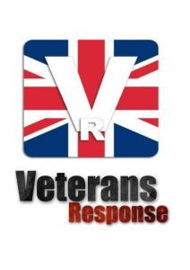
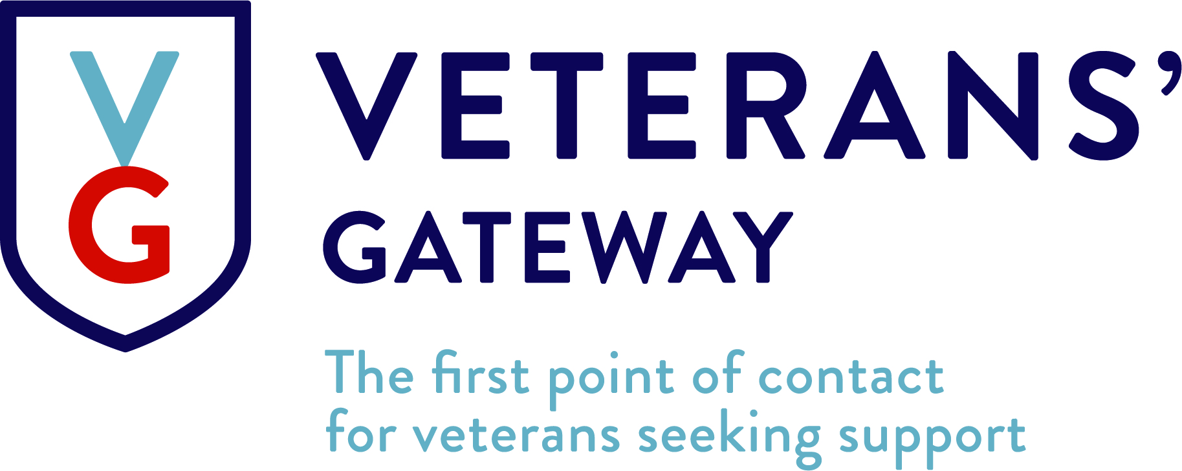

Veterans Response CIC joins key military charities for Veterans’ Gateway

We’re proud to be part of the new Veterans’ Gateway service which promises to be the first point of contact for veterans and their families seeking support.

Independent research commissioned by Veterans’ Gateway shows the military charity sector currently leaves two thirds (64 per cent) of veterans ‘confused’, while one fifth (20 per cent) of veterans having been referred to between three and 10 charities before eventually finding support.

Veterans’ Gateway aims to make this process easier by assessing needs at the first point of contact and connecting people with the right help when they need it, wherever they are.

The service has a network of over 30 expert partners, including Veterans Response CIC coming from across the military and non-military not for profit sector. With more partners being added, the service can help on a number of areas, including:

- Housing
- Employment
- Finances
- Living independently
- Mental wellbeing
- Physical health
- Families and communities

Who is part of Veterans’ Gateway?
Veterans’ Gateway is made up of a consortium of organisations and Armed Forces charities, including The Royal British Legion, SSAFA – the Armed Forces charity, Poppy scotland, Combat Stress and service provider Connect Assist.
Funded by The Armed Forces Covenant, this is the first time a group of this kind has come together formally to deliver a service to help the Armed Forces community.

Charles Byrne, Director General of The Royal British Legion, on behalf of the Veterans’ Gateway consortium said:
“Every charity only exists to help, but Lord Ashcroft revealed the uncomfortable truth that a proliferation of providers in our sector can cause confusion about where to turn. The consortium’s research found that the Armed Forces community – overwhelmingly – supports the Veterans’ Gateway, with 83 per cent welcoming the creation of a first point of contact. Veterans’ Gateway will make it easier for them to get the support they need, from whoever is best able to provide it. No matter how complex their needs, working together we can do more.”
Veterans Have done their duty now it is time to do our duty

Five ways to access Veterans’ Gateway

There are five main ways to contact Veterans’ Gateway, with advisors available 24 hours a day, seven days a week – many of whom are veterans themselves.

- Call the helpline around the clock on 0800 802 1212 / 0191 427 4764
- Visit the website for a host of self-help information and partner information: veteransgateway.org.uk
- Text them on 81212
- Live chat with an advisor online – you’ll find this on the website
- Submit a query using the online form

Craig Slicker, 43 year-old former Lance Corporal in the Army

“When I was told I was leaving, I was given six weeks to find a job and after being in the Army so long, it was a shock to the system. I didn’t know what I could do or what I wanted to do, or where I could turn for advice. A service like Veterans’ Gateway would have been hugely helpful because I had no idea how to find out what support was available to me. I will definitely use it because I’m still struggling financially, just getting used to being paid weekly is a challenge and trying to balance the bills, and I’m still looking for a job that suits my skills.”

